BARC Webmap Instructions

How to Use the Map:
- The user will see the imbedded BARC map on the USDA website listed above.
- The user can scroll and zoom to look at Buildings, Farms, and the BARC boundary but no searches or selections can be made from this view.
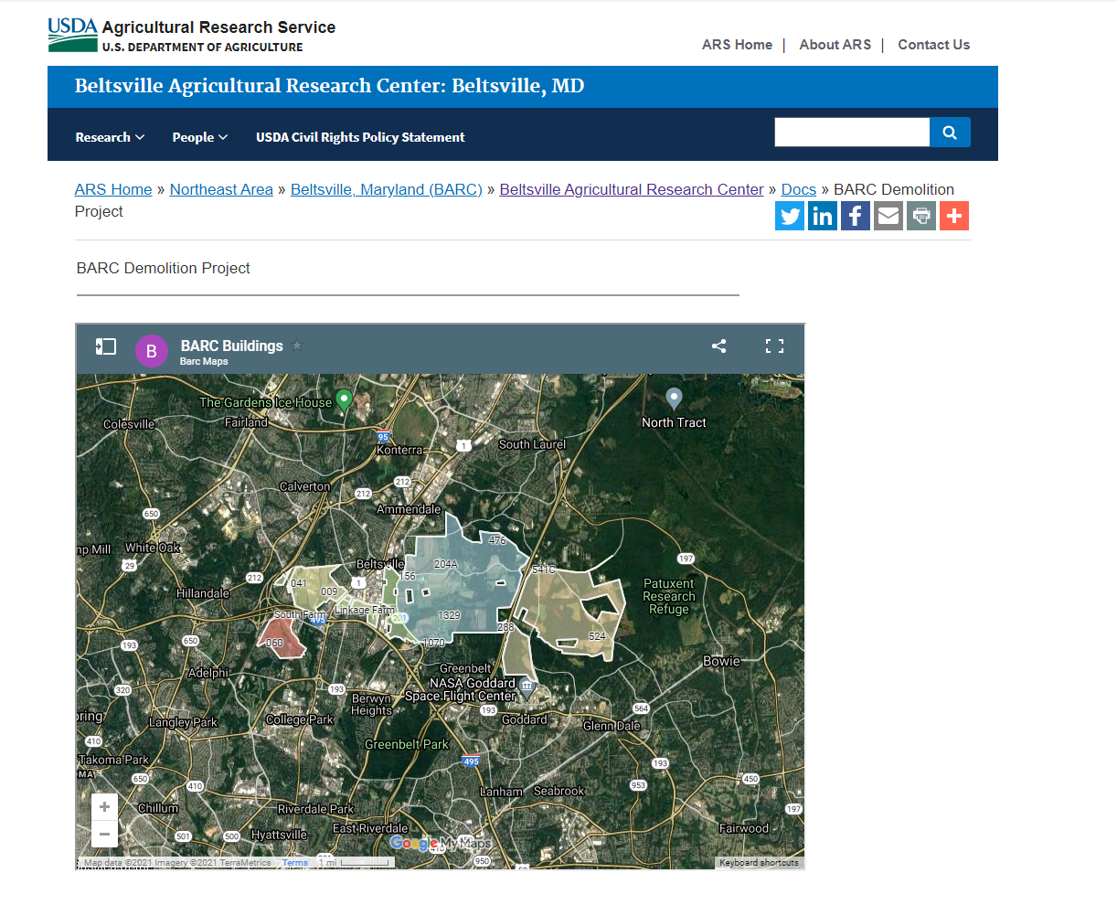
- To make selections or search for sites, select the “View Larger Map” frame icon.
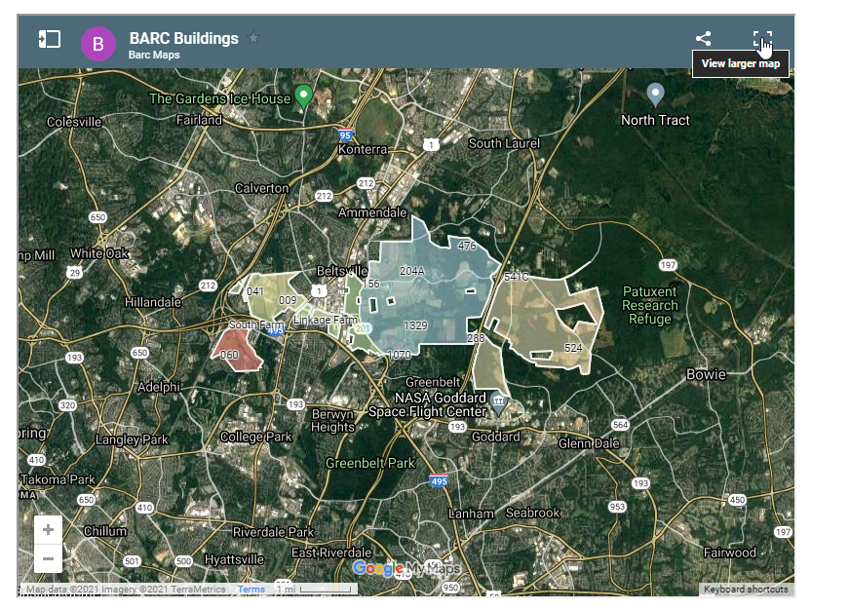
- This view will give the user much more control over what is seen as well as selectable.
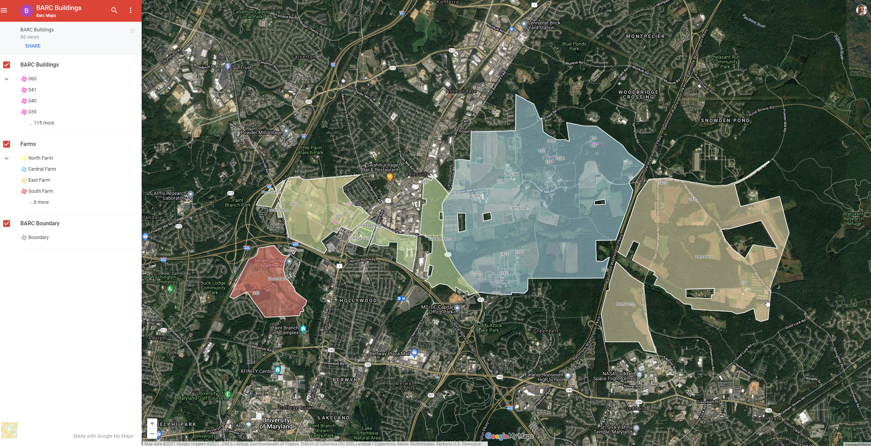
- The bottom left has a small square that can be selected to toggle between streets and aerial view.
- The maps layers are also visible now and can be checked on and off.
- The search tool can be used to search for specific buildings, or they can be selected in the left map pane.
- If only the BARC Buildings layer is checked then the buildings can be clicked in the main map frame that will show building attributes and contain a link to a PDF with information about that building
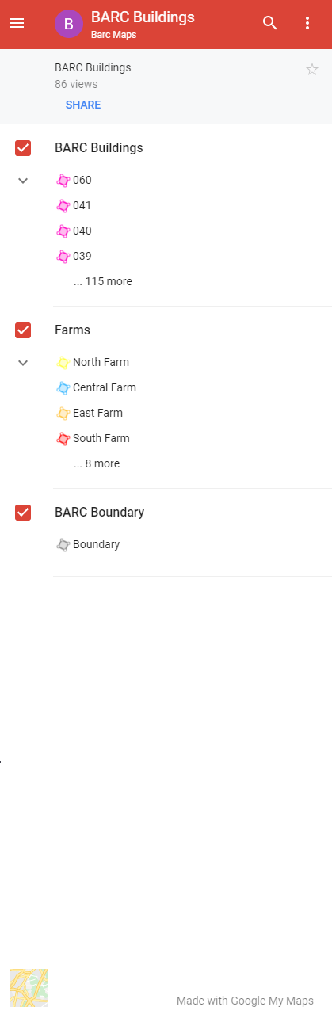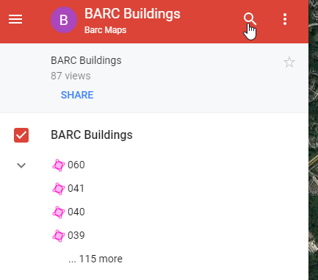

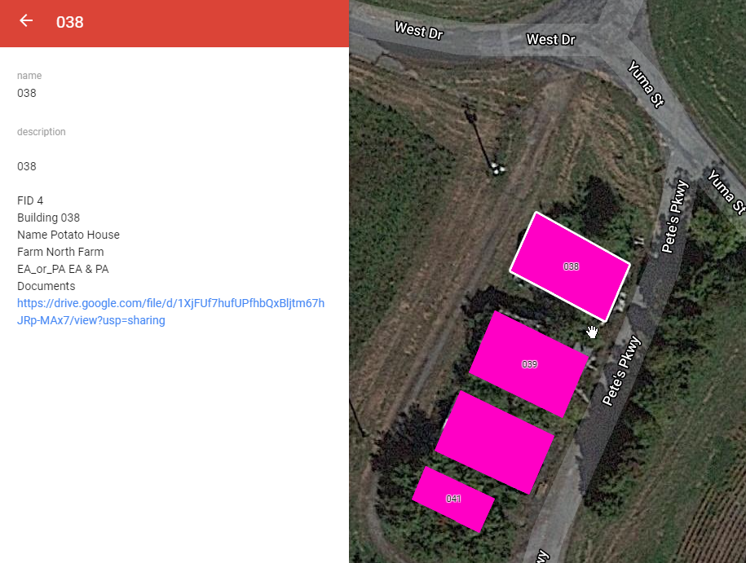
- When the document link is clicked, a PDF will open for that building that contains, photos, forms, maps, survey information, and other relevant site information.
- The non-embedded map link provided has similar usability and functions but with slightly more selection and basemap options.

